**B.TECH. (2020-24)**

**Artificial Intelligence**

Lab File

**Experiment 2**

on

**Basic Simulation Lab**

**[ES204]**

Submitted To

**Ms Shikha Bathla**

Submitted By

**Hitesh**

**A023119820027**

**4CSE11 (AI)**

DEPARTMENT OF COMPUTER SCIENCE AND ENGINEERING

AMITY SCHOOL OF ENGINEERING AND TECHNOLOGY

AMITY UNIVERSITY UTTAR PRADESH

NOIDA (U.P)

**EXPERIMENT- 2**

**AIM**

Performing Matrix Manipulations – Concatenating, Indexing, Sorting, Shifting, Reshaping, Resizing and Flipping about a Vertical Axis / Horizontal Axis; Creating Arrays X & Y of given size (1x N) and Performing

1. Relational Operations – (>, <, ==, <=, >=, ~=)
2. Logical Operations – (~, &, |, XOR)

**SOFTWARE USED**

Octave Online - <https://octave-online.net/>

**THEORY**

MATLAB is a high-performance language for technical computing. It integrates computation, visualization, and programming in an easy-to-use environment where problems and solutions are expressed in familiar mathematical notation.

MATLAB is an interactive system whose basic data element is an array that does not require dimensioning.

MATLAB is an abbreviation for "**mat**rix **lab**oratory." While other programming languages mostly work with numbers one at a time, MATLAB is designed to operate primarily on whole matrices and arrays.

All MATLAB variables are multidimensional arrays, no matter what type of data. A matrix is a two-dimensional array often used for linear algebra.

(I) Matrix Manipulations

1. **Concatenation:** Using MATLAB command cat() as such $\boxed{C = cat(dim,A,B)}$ to concatenate B to the end of A along dimension dim when A and B have compatible sizes (the lengths of the dimensions match except for the operating dimension dim).

$\boxed{C = cat(dim,A1,A2,…,An)}$ concatenates A1, A2, … , An along dimension dim.

Using square bracket operator [] to concatenate. For example, [A,B] or [A B] concatenates arrays A and B horizontally, and [A; B] concatenates them vertically.

1. **Indexing:** The most common way is to explicitly specify the indices of the elements. As such, to access a single element of a matrix, specify the row number followed by the column number of the element.

For example, $\boxed{e = A(3,2)}$, e is the element in the 3,2 position (third row, second column) of A.

You can also reference multiple elements at a time by specifying their indices in a vector. For example, to access the first and third elements of the second row of A, the command would be $\boxed{r = A(2,[1 3])}$.

To access elements in a range of rows or columns, use the colon. For example, to access the elements in the first through third row and the second through fourth column of A, the command is $\boxed{r = A(1:3,2:4)}$.

An alternative way to compute r is to use the keyword “end” to specify the second column through the last column. This approach lets you specify the last column without knowing exactly how many columns are in A.

$$\boxed{r = A(1:3,2:end)}$$

If you want to access all the rows or columns, use the colon operator by itself. For example, to return the entire third column of A, the command would be $\boxed{r = A(:,3)}$.

1. **Sorting:** Using MATLAB command sort() as such $\boxed{B = sort(A)},$ sorts the elements of A in ascending order.

* If A is a vector, then $\boxed{sort(A)}$ sorts the vector elements.
* If A is a matrix, then $\boxed{sort(A)}$ treats the columns of A as vectors and sorts each column.
* If A is a multidimensional array, then $\boxed{sort(A)}$ operates along the first array dimension whose size does not equal 1, treating the elements as vectors.

$\boxed{B = sort(A,dim)}$ returns the sorted elements of A along dimension dim. For example, if A is a matrix, then sort(A,2) sorts the elements of each row.

$\boxed{B = sort(___,direction)}$ returns sorted elements of A in the order specified by direction using any of the previous syntaxes. 'ascend' indicates ascending order (the default) and 'descend' indicates descending order.

1. **Shifting:** Using MATLAB command circshift() as such $\boxed{Y = circshift(A,K)}$, you can circularly shift the elements in array A by K positions. If K is an integer, then circshift() shifts along the first dimension of A whose size does not equal 1. If K is a vector of integers, then each element of K indicates the shift amount in the corresponding dimension of A.

$\boxed{Y = circshift(A,K,dim)}$ circularly shifts the values in array A by K positions along dimension dim. Inputs K and dim must be scalars.

1. **Reshaping and Resizing**: Using MATLAB command reshape() as such $\boxed{B = reshape(A,sz)}$ reshapes A using the size vector, sz, to define size(B). For example, reshape(A,[2,3]) reshapes A into a 2-by-3 matrix. sz must contain at least 2 elements, and prod(sz) must be the same as numel(A).

$\boxed{B = reshape(A,sz1,...,szN)}$ reshapes A into a sz1-by-...-by-szN array where sz1,...,szN indicates the size of each dimension. You can specify a single dimension size of [] to have the dimension size automatically calculated, such that the number of elements in B matches the number of elements in A.

For example, if A is a 10-by-10 matrix, then $\boxed{reshape(A,2,2,[])}$ reshapes the 100 elements of A into a 2-by-2-by-25 array.

1. **Flipping**: Using MATLAB command flip() as such $\boxed{B = flip(A)}$, returns array B the same size as A, but with the order of the elements reversed. The dimension that is reordered in B depends on the shape of A: -

* If A is vector, then flip(A) reverses the order of the elements along the length of the vector.
* If A is a matrix, then flip(A) reverses the elements in each column.
* If A is an N-D array, then flip(A) operates on the first dimension of A in which the size value is not 1.

$\boxed{B = flip(A,dim)}$ reverses the order of the elements in A along dimension dim.

For example, if A is a matrix, then $\boxed{flip(A,1)}$ reverses the elements in each column, and $\boxed{flip(A,2)}$ reverses the elements in each row.

1. **Rotation**: Using MATLAB command rot90() as such $\boxed{B = rot90(A)}$ rotates array A counterclockwise by 90 degrees. For multidimensional arrays, rot90 rotates in the plane formed by the first and second dimensions.

$\boxed{B = rot90(A,k)}$ rotates array A counterclockwise by k*90 degrees, where k is an integer.

Using Octave command rotdim() as such $\boxed{rotdim (x[, n, plane])}$, it returns a copy of x with the elements rotated counterclockwise in 90-degree increments.

The second argument n is optional and specifies how many 90-degree rotations are to be applied (the default value is 1). Negative values of n rotate the matrix in a clockwise direction.

The third argument is also optional and defines the plane of the rotation. If present, plane is a two-element vector containing two different valid dimensions of the matrix. When plane is not given the first two non-singleton dimensions are used.

(II) Performing Relational Operations on 2 arrays X & Y of given size (1xN)

Relational operators can also work on both scalar and non-scalar data. Relational operators for arrays perform element-by-element comparisons between two arrays and return a logical array of the same size, with elements set to logical 1 (true) where the relation is true and elements set to logical 0 (false) where it is not.

|  |  |  |  |
| --- | --- | --- | --- |
| **S.No.** | **Operator** | **MATLAB Command/Function** | **Description** |
| **1** | < | lt(a,b) | Tests whether a is less than b |
| **2** | <= | le(a,b) | Tests whether a is less than or equal to b |
| **3** | > | gt(a,b) | Tests whether a is greater than b |
| **4** | >= | ge(a,b) | Tests whether a is greater than or equal to b |
| **5** | == | eq(a,b) | Tests whether a is equal to b |
| **6** | ~= | ne(a,b) | Tests whether a is not equal to b |
| **7** |  | isequal(a,b) | Determine array equality, treating NaN values as unequal |
| **8** |  | isequaln(a,b) | Determine array equality, treating NaN values as equal |

(III) Performing Logical Operations on 2 arrays X & Y of given size (1xN)

MATLAB represents Boolean data using the logical data type. This data type represents true and false states using the numbers 1 and 0, respectively. Certain MATLAB functions and operators return logical values to indicate fulfilment of a condition.

1. **Logical NOT**: Using tilde operator (~) as such $\boxed{\sim A}$, returns a logical array of the same size as A. The array contains logical 1 (true) values where A is zero and logical 0 (false) values where A is nonzero.

Alternatively, use MATLAB command $\boxed{not(A)}$ to execute ~A.

1. **Logical** **AND**: Using ampersand operator (&) as such $\boxed{A \& B}$ to perform a logical AND of arrays A and B and to return an array containing elements set to either logical 1 (true) or logical 0 (false). An element of the output array is set to logical 1 (true) if both A and B contain a nonzero element at that same array location. Otherwise, the array element is set to 0.

Using MATLAB command $\boxed{and(A,B)}$ is an alternate way to execute A & B.

1. **Logical** **OR**: Using operator (|) as such $\boxed{A | B}$ to perform a logical OR of arrays A and B and to return an array containing elements set to either logical 1 (true) or logical 0 (false). An element of the output array is set to logical 1 (true) if either A or B contain a nonzero element at that same array location. Otherwise, the array element is set to 0.

Using MATLAB command $\boxed{or(A,B)}$ is an alternate way to execute A | B.

1. **Logical** **Exclusive-OR**: Using MATLAB command $\boxed{C = xor(A,B)}$ to perform a logical exclusive-OR of arrays A and B and to return an array containing elements set to either logical 1 (true) or logical 0 (false). An element of the output array is set to logical 1 (true) if A or B, but not both, contains a nonzero element at that same array location. Otherwise, the array element is set to 0.

**PROGRAM CODE**

**RESULTS**

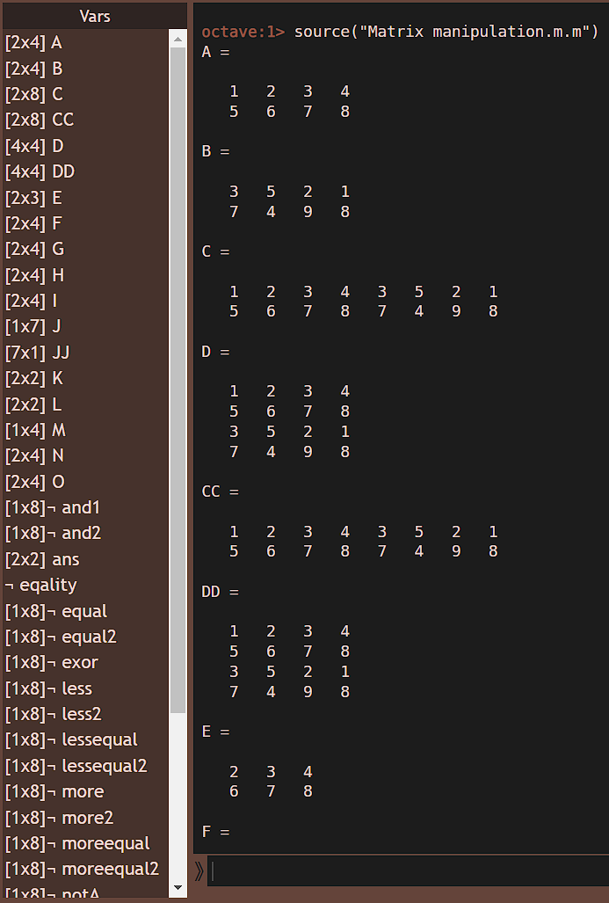 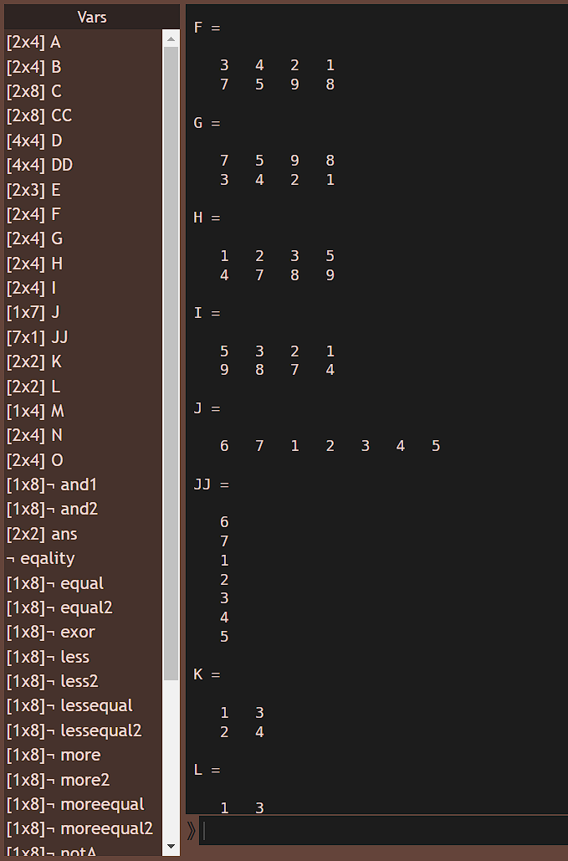

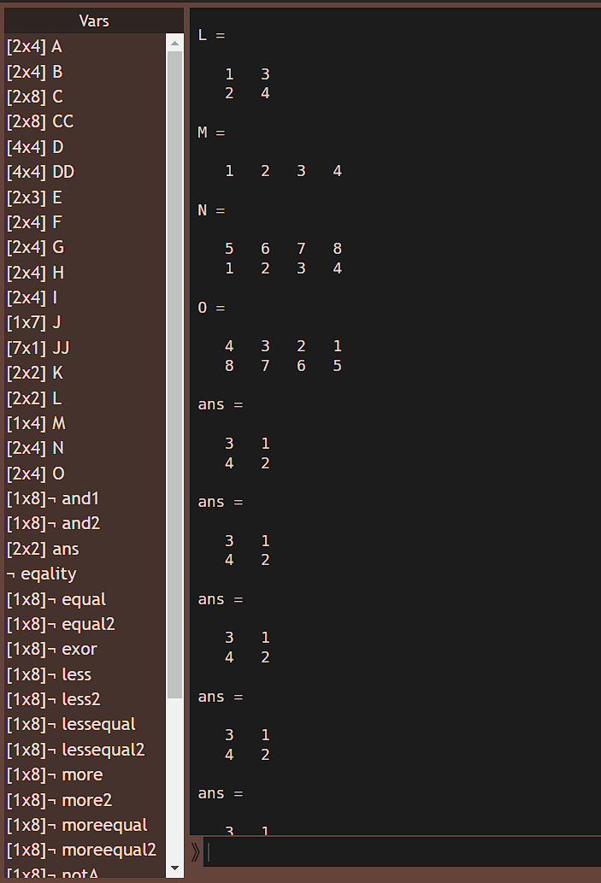 

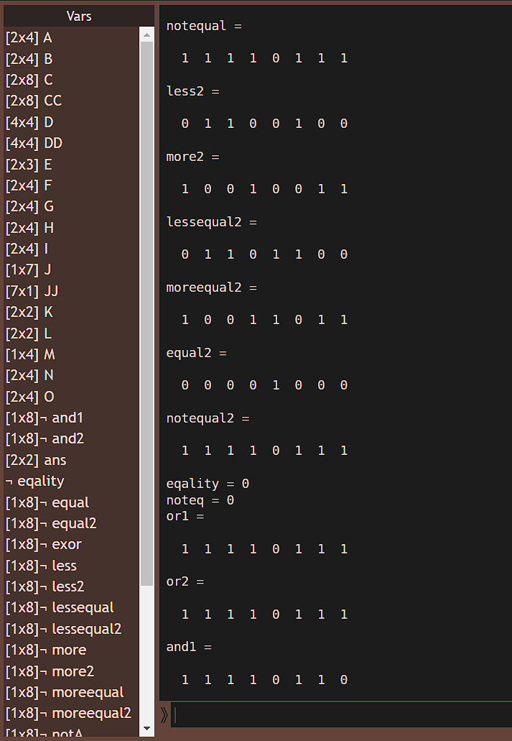 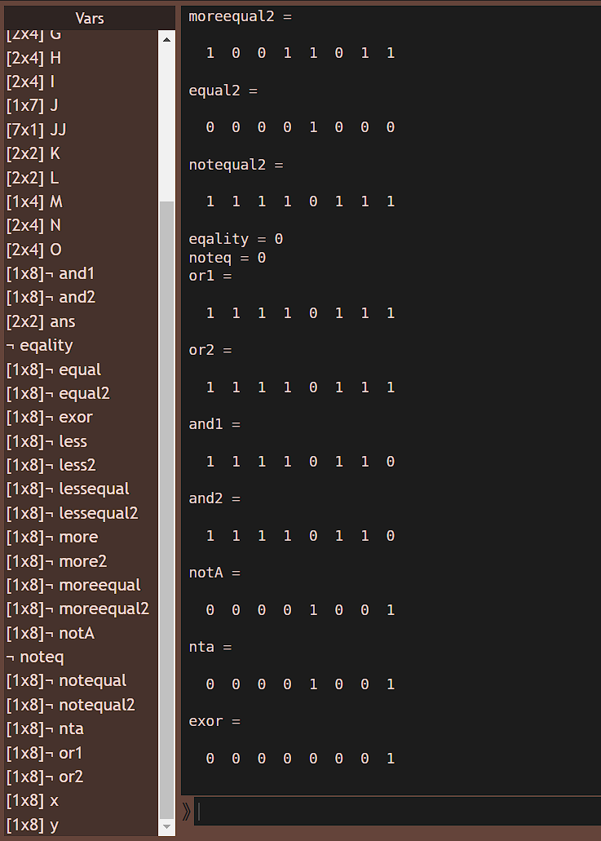

**CONCLUSION**

The several MATLAB commands have been explored and successfully used to perform Matrix Manipulations – Concatenating, Indexing, Sorting, Shifting, Reshaping, Resizing and Flipping about a Vertical Axis / Horizontal Axis, and to create Arrays X & Y of given size (1x N) and performing relational and logical operations on them.

**PRECAUTIONS**

* Don’t forget to save the code after every change you make.
* Use MATLAB properly.
* MATLAB requires a stable network connection.
* Save the file after compiling the code and take the required notes and screenshots, so that you don’t have to open octave and do everything again.

|  |  |  |  |
| --- | --- | --- | --- |
| **Criteria** | **Total Marks** | **Marks Obtained** | **Comments** |
| Concept (A) | 2 |  |  |
| Implementation (B) | 2 |  |  |
| Performance (C) | 2 |  |  |
| Total | 6 |  |  |